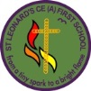 | (KS1)  Space Explorers |  |  |  |  | 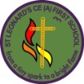
What is this learning quest about?
This learning quest enables our pupils to appreciate and place themselves in the wider world. It is one to inspire awe and wonder, to stimulate curiosity about the world pupils live in. This quest begins the year to support our pupil’s ambition for the year ahead using inspirational characters to show them that they too can achieve amazing things in their lifetime if they endeavour and persevere.
Pupils will learn about the planet Earth on which they live, learning their own home address and extending out to the world and further into space learning about the other planets in our solar system. They will gain a sense of why people of the past and future continue to find out more about space and how historical events have changed our world with the exploration of the moon. Pupils will use their geographical skills in different contexts to those previously studied by exploring the mapping of the moon. Pupils will apply their science knowledge to the context of space through their study of materials and the seasons. They will be challenged to read and research and remember facts about space. Pupils will be introduced to the range of art skills which they will develop over the year. They will explore each one in response to the work of a famous artist who was inspired by space. Pupils will have a go at being space engineers through their design and make study of moon buggies. Pupils will consider how well people look after the precious world we have been given and explore ways to preserve the world’s resources.
Big Question |  |  | Quest Characters |  | Core Value
Is there anything bigger than the universe? |  |  | Neil Armstrong  Tim Peake  Helen Sharman |  | Curiosity
Global Education |  |  | Learning Behaviour |  | British Values
Responsible consumption and production |  |  | Exploring Elephant  Creative Chameleon |  | Liberty/ Freedom
KEY AREAS OF LEARNING  Engage, Innovate and Express |  |  |  |  | Assessment
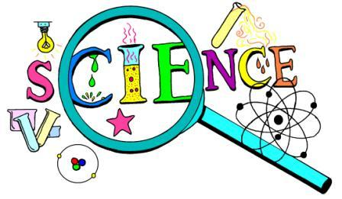 |  | Wow Science – Investigative skills/ Space  Year 1  - I can name materials used in space.  - I link properties of materials to an application with support.  - I remember some simple facts about Science (space).  Year 2  - I can compare the suitability of materials for use in space.  - I link properties of materials to an application independently.  - I can remember relevant science facts (space) with some confidence.  Seasonal change introduction  Year 1  - I observe changes across the four seasons.  - I know why the seasons and weather occurs.  - I know why day length varies. |  |  | Key knowledge  What are the 4 seasons of the year?  Describe each season.  Why do the seasons change and days get longer and shorter?  Is a space rocket made from wood? Why not?  What are the planets in our solar system called?  Skills  I can remember science facts.  What are the planets in our solar system called?  What effect does the moon have on us on Earth?
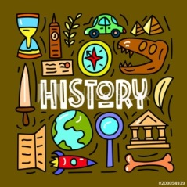 |  | Within Living Memory (1969)  An aspect of change in National Life contributing to National and International achievements  Famous People- Neil Armstrong/ The Moon Landing  Year 1  - I can name a famous person from the past and explain why they are famous.  - I can use stories to help me distinguish between fact and fiction.  Year 2  - I know about a famous person from outside the UK and explain why they are famous.  - I can compare two versions of a past event. |  |  | Key Knowledge  Why is Neil Armstrong famous?  Where did he live?  Where is the moon?  When did the first man step on the moon?  How did he get to the moon?  How did this affect the whole world, why was it so important?  Skills  I can distinguish between fact and fiction in sources.  I can compare 2 versions of the moon landing and describe which I think is more accurate and why.
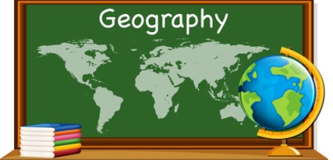 |  | Geographical skills and fieldwork  Compass directions/Locational and directional language  Year 1  - I can follow directions up, down, left and right, forward, back, next to, below.  - I know my address including my postcode.  - I can use my own symbols on an imaginary map (map of the moon).  Year 2  - I can follow directions as Y1 including North, South, East and West.  - I can recognise NSEW on a compass.  - I can follow a route on a map (moon map).  - I can use an aerial photograph to recognise landmarks. |  |  | Key Knowledge  Why are symbols used on a map?  What is your home address and postcode?  What is NSEW needed for?  How does a compass work?  Skills  I can draw a compass with NSEW.  I can follow directions and a route on a map.  I can find landmarks on an aerial photograph.
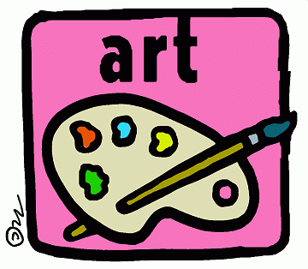 |  | Range of Space Art – Proficiency in Art Skills/ Great Artists  Drawing (Pablo Picasso – Pen and Ink constellations)  Georgio O’Keefe Starlit night  Wassily Kandinsky – Several circles  Andy Warhol – Moon walker  - I can use a range of materials creatively to design and make products.  - I can develop ideas for my work from starting points.  Drawing  Year 1  - I can explore the use of line and shape.  Year 2  - I can experiment with the visual elements of line and shape.  Painting  Year 1  - I can use different types of paint.  Year 2  - I can name different types of paint and their properties.  Printing  Year 1  - I can make marks by imprinting with objects.  Year 2  - I can print using a variety of objects.  ICT  Y1 and Y2  - I can use ICT to produce Art.  - I can investigate photography. |  |  | Key Knowledge  What makes an artist great?  Describe the artwork of one of the artists you have studied? What style do they use?  Can you name some different types of paint?  Skills  I understand the skills I need to develop this year in drawing, painting, printing and using ICT.  I can develop ideas from the starting points of different artists.
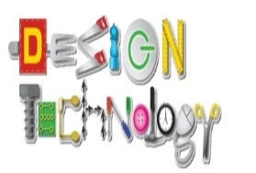 |  | Moon Buggies  Y1  - I can use wheels and axles in my product.  - I can assemble, join and combine materials and components using a variety of temporary methods.  - I can develop ideas through talk and drawing.  - I can evaluate my product and how well it works.  Y2  - I can select the best tools and materials and use the correct vocabulary to name them.  - I can join things together in different ways.  - I can develop ideas through talk and drawing and label the parts.  - I can evaluate my product and how well it works.  - I can evaluate my product during construction. |  |  | Key Knowledge  Why are moon buggies used in space?  What makes a good moon buggy?  Can you name the main parts of a buggy?  Describe how the wheels go around on a buggy.  Skills  I can draw a moon buggy design and label it.  I can choose the tools and materials to use.  I can assemble, join and combine materials to make my moon buggy.  I can evaluate my moon buggy.
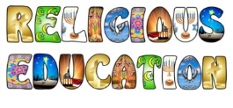 |  | Belonging  What does it mean to belong to a faith community?
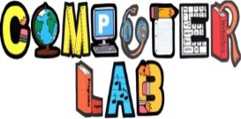 |  | Computing systems and networks  Year1 - Technology around us Recognising technology in school and using it responsibly.  Year 2 - Information Technology around us Identifying IT and how its responsible use improves our world in school and beyond.  Digital Literacy – Managing online information  Year 1  - I can use the internet to find things out.  - I can use simple keywords in search engines.  - I can describe and demonstrate how to get help from a trusted adult or helpline if I find content that makes me feel sad, uncomfortable worried or frightened.  Year 2  - I can use keywords in search engines.  - I can demonstrate how to navigate a simple webpage to get to information I need (e.g. home, forward, back buttons; links, tabs and sections).  - I can explain what voice activated searching is and how it might be used (e.g. Alexa, Google Now, Siri).  - I can explain the difference between things that are imaginary, ‘made up’ or ‘make believe’ and things that are ‘true’ or ‘real’.  - I can explain why some information I find online may not be true. |  |  | Digital Literacy - https://projectevolve.co.uk/toolkit/ Computing - https://teachcomputing.org/curriculum/key-stage1
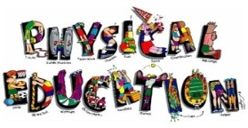
Citizenship – The Environment
- I know what improves and harms their local, natural and built environments.
- I know how to care for the environment.
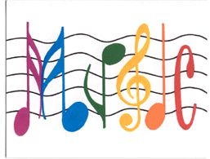
 |  |  |  |  | Our planet has provided us with an abundance of natural resources. But we have not utilized them responsibly and currently consume far beyond what our planet can provide. We must learn how to use and produce in sustainable ways that will reverse the harm that we have inflicted on the planet.
 |  | 