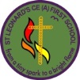 | Flames Class (KS2)  Space Explorers
What is this curiosity quest about?
This learning quest enables our pupils to appreciate and place themselves in the wider world. It is one to inspire awe and wonder, to stimulate curiosity about the world pupils live in. This quest begins the year to support our pupil’s ambition for the year ahead using inspirational characters to show them that they too can achieve amazing things in their lifetime if they endeavour and persevere.
Pupils will learn about the planet Earth on which they live, learning their own home address and extending out to the world and further into space learning about the other planets in our solar system. They will gain a sense of why people of the past and future continue to find out more about space and how historical events have changed our world with the exploration of the moon. Pupils will use their geographical skills in different contexts to those previously studied by exploring the mapping of the moon. Pupils will apply their science knowledge to the context of space through their study of materials and the seasons. They will be challenged to read and research and remember facts about space. Pupils will be introduced to the range of art skills which they will develop over the year. They will explore each one in response to the work of a famous artist who was inspired by space. Pupils will have a go at being space engineers through their design and make study of moon buggies. Pupils will consider how well people look after the precious world we have been given and explore ways to preserve the world’s resources.
Big Question |  |  | Quest Characters |  |  | Core Value
Is there anything bigger than the universe? |  |  | Neil Armstrong  Tim Peake  Helen Sharman |  |  | Curiosity
Global Education |  |  | Learning Behaviour |  |  | British Values
Responsible consumption and production |  |  | Exploring elephant  Creative chameleon |  |  | Liberty and Freedom
KEY AREAS OF LEARNING
Engage, innovate and express
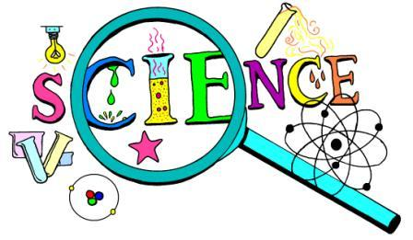 |  | Wow Science - Space  Year 3  - I am beginning to use science models to describe.  Year 4  - I can use science models to describe.  Magnetism  Year 3  - I know that magnets have 2 poles.  - I know that magnetic forces can act at a distance.  - I observe how magnets can attract and repel each other.  - I know that magnets attract some materials and not others.  - I can compare and group a variety of materials (magnetic and non-magnetic).  - I can predict whether 2 magnets will attract or repel each other based on which poles are facing.  - I can compare the behaviour of a range of magnets.  - I can investigate the strength of different magnets. |  |  | Key Knowledge  Describe how a magnetic force works.  Which materials are attracted to a magnet?  Which materials are not attracted to a magnet?  Can you name different types of magnet and say how they behave?  Skills  I can sort objects into magnetic and non-magnetic.  I can predict what will happen with magnetic forces.  I can carry out an investigation using magnets.
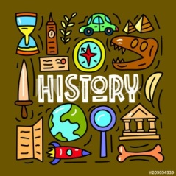 |  | Beyond 1066/ Space travel - Moon landing (1969)  Year 3  - I can distinguish between different sources.  - I can compare different versions of the same event  - I can understand why people may have wanted to do something in the past.  - I can select and record information relevant to the study.  Year 4  - I am beginning to evaluate the usefulness of different sources.  - I can choose relevant material to present a picture of an aspect of time past. |  |  | Key Knowledge  Why was the Apollo 11 moon landing so important?  Who went on the mission and how long did it take?  Describe what the astronauts did whilst they were there.  Describe the main events in the chronology of space travel.  Skills  Y3 – I can compare different versions of the same story.  I can select and record information relevant to the study.  Y4 – I can choose relevant material to present a picture of an aspect of time past (moon landing).  I am beginning to evaluate the usefulness of sources.
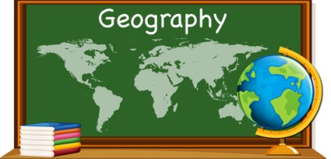 |  | Geographical skills and fieldwork  Direction and Location  Year 3  - I can use 4 compass points to follow/ give directions.  - I can use letter/ number co-ordinates to locate features on a map.  Year 4  - I am beginning to use 8 compass points.  - I can do the above confidently.  Locational knowledge  Year 3  - I know where the Arctic and Antarctic Circle are on a world map.  - I know the names of 4 countries from the southern and 4 from the Northern hemispheres.  - I know the names of and can locate 8 European countries.  Year 4  - I know what is meant by the term ‘tropics’.  - I know where the Equator, Tropic of Cancer and Capricorn and Greenwich Meridian are on a world map. |  |  | Key Knowledge  Can you name 4 countries from the Southern hemisphere of the world?  Can you name 4 countries from the Northern hemisphere of the world?  What are the tropics?  Skills  I can locate countries on the world map.  I can locate the Arctic and Antarctic Circle on the world map.  I can use compass points to give and follow directions.  I can use letter/ number co-ordinates to locate features on a map.  I can locate the Equator, Tropics and Greenwich Meridian on a world map.
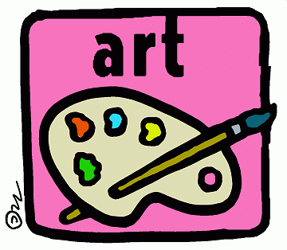 |  | Range of Space Art – Proficiency in Art Skills/ Great Artists  Drawing (Pablo Picasso – Pen and Ink constellations)  Georgio O’Keefe Starlit night  Wassily Kandinsky – Several circles  Andy Warhol – Moon walker  - I can question and make thoughtful observations about starting points for my work.  Drawing  Year 3  - I can use different media to achieve variation in line and shape (biro).  Year 4  - I can alter and refine line drawings using Art vocabulary.  Painting  Year 3  - I can experiment with colour washes.  Year 4  - I can plan and create different effects with paint.  Printing  Year 3  - I can print using objects and use layering techniques.  Year 4  - I can select a type of material to print with to get the effect I want.  ICT  Y3 and 4  - I can use ICT to present my artwork. |  |  | Key knowledge  Choose an artist from those you have studied. Explain their artistic style.  Choose a word from the Art vocabulary list and explain what it means.  Skills  I can use the style of an artist in my own work.  I can vary line and shape.  I can use Art vocabulary.  I can layer my printing.  I can experiment with paint.
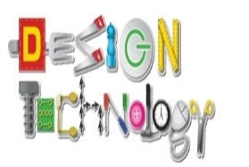 |  | ROCKETS  Y3 and Y4  - Learn about inventors and engineers who have developed rockets (including Isaac Newton Scientist discovered gravity).  - Start to understand that mechanical pneumatic systems create movement.  - Suggest some improvements and say what was good and not so good about their original design.  Year 3  - Put together a step by step plan which shows the order and also which equipment and tools they need.  - Measure, mark out, cut and score and assemble components with more accuracy.  Year 4  - Generate ideas considering their scientific knowledge.  - Confidently make labelled drawings from different angles to show specific features.  - Develop a clear ideas of what has to be done. Plan how to use materials and processes with alternatives of ideas fail.  - Explain their product to others. Present it in an interesting way. |  |  | Key Knowledge  What is a pneumatic system?  Describe an inventor or engineer you have learnt about.  Explain how you made your rocket step by step.  Skills  I can use a pneumatic system in my rocket design.  I can draw a labelled diagram of my design.  I can measure, mark out, cut and score to assemble my design.  I can evaluate my design.
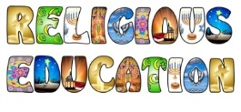 |  | Belonging (How do people of other faiths pray?)
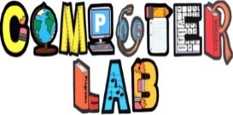 |  | Computer Science  Computing systems and networks  Year 3 - Connecting computers (Part 1) Identifying that digital devices have inputs, processes, and outputs, and how devices can be connected to make networks.  Year 4 - The Internet (Part 1) Recognising the internet as a network of networks including the WWW, and why we should evaluate online content  Digital Literacy  Managing Online Information  Year 3  - I can use key phrases in search engines  - I can explain what autocomplete is and how to choose the best suggestion  - I can explain how the internet can be used to sell and buy things.  - I can explain the difference between a ‘belief’, an ‘opinion’ and a ‘fact’.  Year 4  - I can analyse information and differentiate between ‘opinions’, ‘beliefs’ and ‘facts’. I understand what criteria have to be met before something is a ‘fact’.  - I can describe how I can search for information within a wide group of technologies (e.g. social media, image sites, video sites).  - I can describe some of the methods used to encourage people to buy things online (e.g. advertising offers; in app purchases, pop-ups) and can recognise some of these when they appear online.  - I can explain that some people I ‘meet online’ (e.g. through social media) may be computer programmes pretending to be real people.  - I can explain why lots of people sharing the same opinions or beliefs online does not make those opinions or beliefs true. |  |  | Digital Literacy - https://projectevolve.co.uk/toolkit/ Computing - https://teachcomputing.org/curriculum/key-stage1
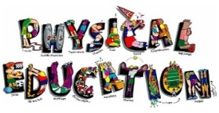
Citizenship
- I can consider my own environment and identify changes which I could make to improve it.
- I understand that money given from government is allocated to provide services and ensure a good, clean and safe environment.
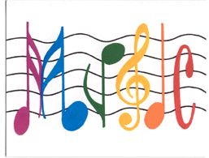
 |  |  |  | Our planet has provided us with an abundance of natural resources. But we have not utilized them responsibly and currently consume far beyond what our planet can provide. We must learn how to use and produce in sustainable ways that will reverse the harm that we have inflicted on the planet.
 |  | 